Mythical Index Site Plan

Spencer T. Crosland

WDD 131-A1

Overview

Purpose

The purpose of this site is to teach visitors about famous mythical creatures from different cultures around the world. The site will provide descriptions, origins, abilities, and interesting facts about creatures such as dragons, wraiths, and Wendigo.

Audience
The audience for this site includes students, fantasy fans, and anyone interested in mythology or legendary creatures. The content is designed to be easy to read and educational while also being entertaining.

Dynamic elements
JavaScript will provide several interactive features on the site.
- A list of mythical creatures stored in an array of objects
- Creatures will be displayed dynamically on the page using JavaScript
- Users can filter creatures by culture with origins page drop down menu
- Users can use a search bar to find creatures, abilities, or origins
- Clicking on a creature will display more detailed information to the side and enlarge a gallery image of the creatures
- JavaScript will use array methods such as filter() and forEach()
- Event listeners will react to button clicks or dropdown selections

Branding

Website Logo
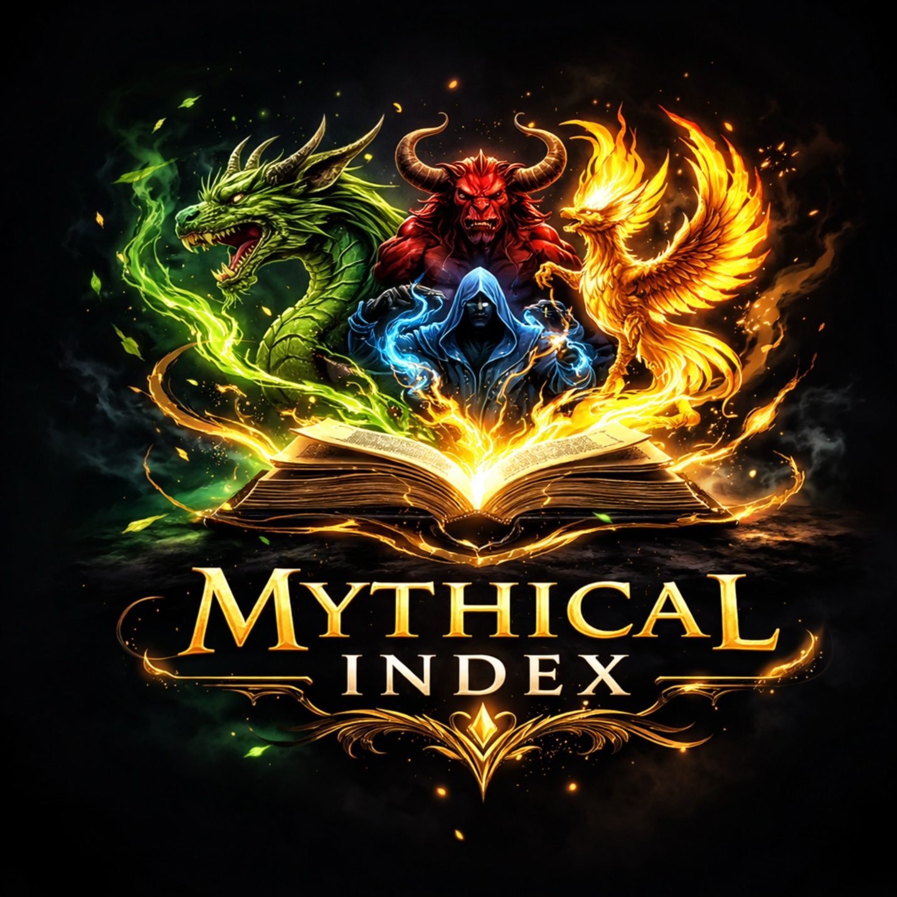

Style Guide

Color Palette
Palette URL: https://coolors.co/396e94-e7c24f-a43312-381d2a-aabd8c
Primary | Secondary | Accent 1 | Accent 2
  [#E7C24F] |   [#DC4618] |   [#511414] |   [#6B8E23]

Typography

Heading Font: Cinzel

Paragraph Font: Lora

Normal paragraph example
Lorem ipsum dolor sit amet, consectetur adipiscing elit, sed do eiusmod tempor incididunt ut labore et dolore magna aliqua. Ut enim ad minim veniam, quis nostrud exercitation ullamco laboris nisi ut aliquip ex ea commodo consequat. Duis aute irure dolor in reprehenderit in voluptate velit esse cillum dolore eu fugiat nulla pariatur. Excepteur sint occaecat cupidatat non proident, sunt in culpa qui officia deserunt mollit anim id est laborum.

Colored paragraph example (#E7C24F) 
Lorem ipsum dolor sit amet, consectetur adipiscing elit, sed do eiusmod tempor incididunt ut labore et dolore magna aliqua. Ut enim ad minim veniam, quis nostrud exercitation ullamco laboris nisi ut aliquip ex ea commodo consequat.

Navigation
Home Creatures Origins

Content

Home page
The home page introduces the topic of mythical creatures and explains what mythology is.
Content includes:
- Introduction to mythology
- Featured creatures section
Example creatures displayed:
- Dragon
- Wraith
- Wendigo
Each creature will include:
- Name
- Culture of origin
- Short description
- Image

Creatures Page
This page lists multiple mythical creatures and allows users to interact with them.
Content includes:
- Grid or card layout of creatures
- Image of each creature
- Short description
- Origin culture
Example creatures:
- Dragon (Norse mythology)
- Kraken (Norse mythology)
- Wraith (Norse mythology)
- Griffin (Greek mythology)
- Minotaur (Greek mythology)
- Phoenix (Greek mythology)
- Wendigo (Native American mythology)
- Skinwalker (Native American mythology)
- Sasquatch (Native American mythology)

Users can:
- Filter creatures by attributes, culture, or name using the search bar
- Click a creature to see more information and enlarge the gallery image
Images:
- Creature illustrations or artwork

Origins Page
This page will have a drop down menu for the user to use that will display the mythical creatures from each culture.

Content includes:
- Grid or card layout of creatures
- Image of each creature
- Short description
- Origin culture

Creatures by Origin:
Norse
  - Dragon (Norse mythology)
  - Kraken (Norse mythology)
  - Wraith (Norse mythology)
  - Valkyries
  - Dwarfs
  - Elves
Greek
  - Griffin (Greek mythology)
  - Minotaur (Greek mythology)
  - Phoenix (Greek mythology)
  - Titans
  - Cyclops
  - Sirens
Native American
  - Wendigo (Native American mythology)
  - Skinwalker (Native American mythology)
  - Sasquatch (Native American mythology)
  - Thunderbird
  - Pukwudgies
  - Kushtaka
Users can:
- Click a creature to see more information and enlarge the gallery image

Wireframe

Create two wireframes for your site. One for each page and list them here

Home

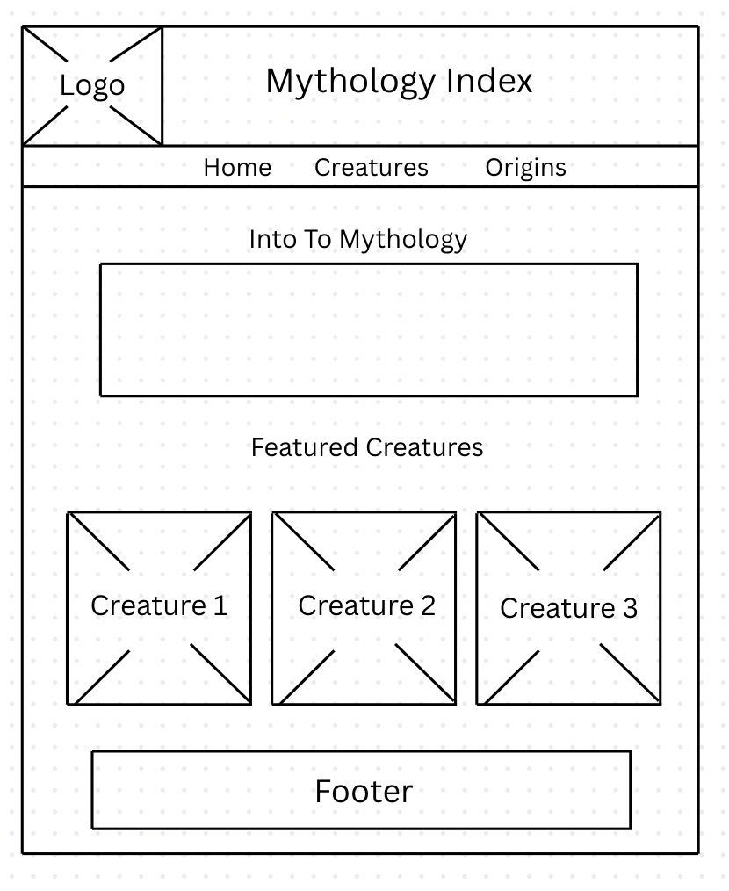

Creature Page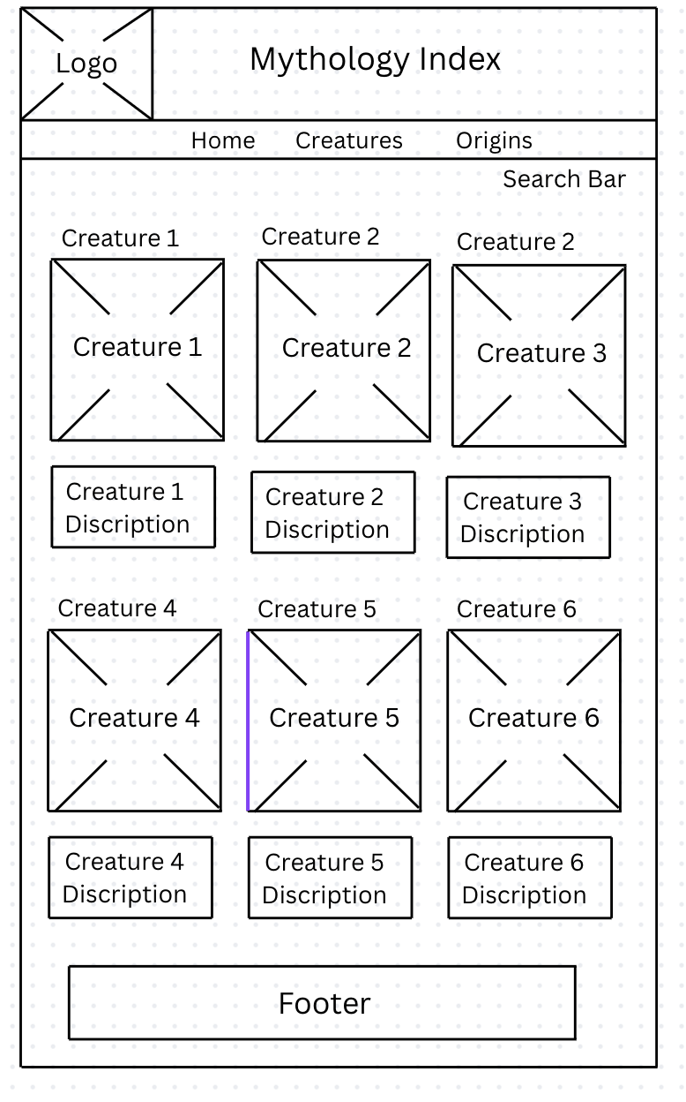

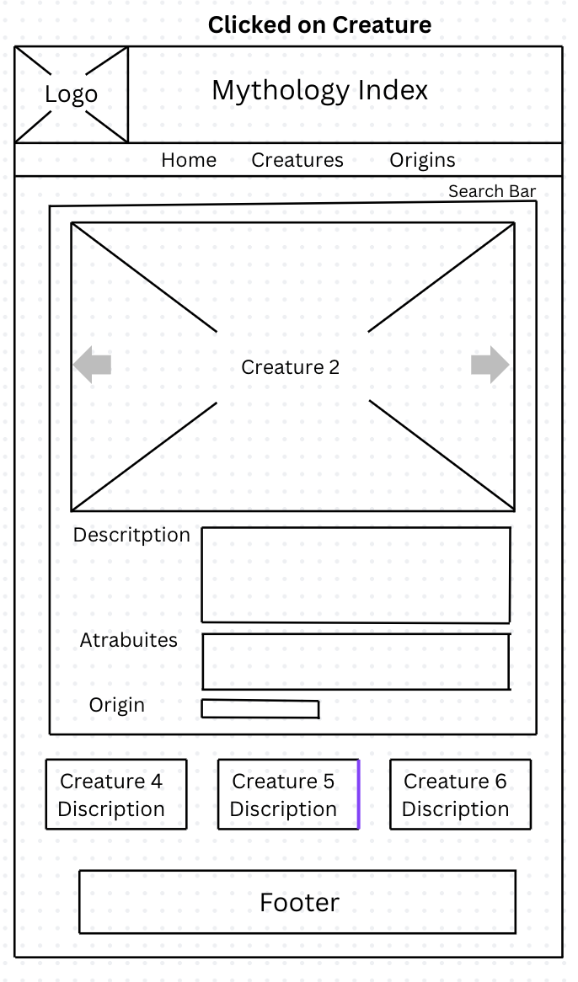

Origin Page
